**Vibrations and Waves Lab/Activity**

1. In an area free from obstacles, stretch out a slinky so that the turns are a few centimeters apart. Mark the positions of each end with masking tape. Measure the distance between pieces of tape.

D = _______ meters

1. With the slinky stretched out to the tape, hold the spring near one of the ends and pull 20 cm sideways and back. This works best if you snap your wrist back and forth (a quick snap!) What is the shape of the spring? Draw it.

You have just made a TRANSVERSE wave (pulse).

1. What direction does the *slinky* move or vibrate as the pulse (one ‘jerk’) travels down it? (forward and backward, or side to side)
2. A dictionary definition of the word transverse is: “Situated or lying across”. In terms of the *direction* of the pulse, and the *direction* of the slinky’s vibration, why is this a good name for the wave you observed?
3. Repeat step 1, and measure the amplitude of the wave. The distance you disturbed the spring (how far you pulled it out sideways) is called the AMPLITUDE. The amplitude tells how much the spring is displaced – it’s the height of the wave.

Amplitude = __________ meters

Do you think that the amplitude effects the speed of the pulse? We’ll find out:

After you have experimented making pulses, measure the average speed of the pulse for different amplitudes. You will need to measure the time it takes for the pulse to travel the length of the spring. Take several measurements, then find the average.

|  |  |  |  |  |  |
| --- | --- | --- | --- | --- | --- |
| Amplitude (meters) | Time 1 | Time 2 | Time 3 | Time (average) | Speed (d/t) |
|  |  |  |  |  |  |
|  |  |  |  |  |  |
|  |  |  |  |  |  |
|  |  |  |  |  |  |

How does the speed of the pulse depend on amplitude?

1. Now make waves!! Swing one end back-and-forth (with a regular time interval) over and over again along the floor. The result is called a periodic wave.
2. Describe the appearance of the periodic wave you created. Draw it.
3. To make these waves look very simple, change the way you swing the end until you swing the end until you see large waves that do not move along the spring – the pattern is kind of frozen. (this may have already happened naturally) You will see points where the spring does not move at all (nodes). The wave appears to be standing still. These waves are called STANDING WAVES.

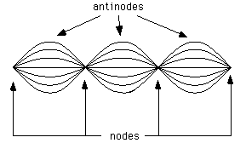

1. At any moment in time, the distance from one crest (top of the wave) to another is called the WAVELENGTH (length of one wave – see figure 2 below). Notice that you can also find the wavelength by looking at the nodes. The wavelength is twice the distance between two nodes. Measure the length wavelength of your standing wave.

Wavelength = __________ meters

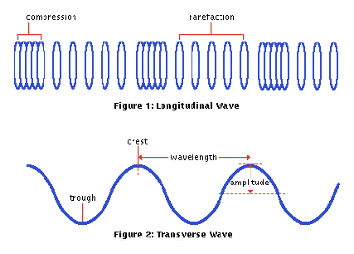

1. Next, you will measure the frequency of your wave. The frequency is the number of waves that go by a point in a given amount of time. Measure the frequency of your standing wave. (Hint: Watch the hands of the person shaking the spring. You could count the number of vibrations in 10 seconds. Frequency = # of vibrations / time)

Frequency = ________ cycles / second

When frequency is measured in *cycles per second* (as opposed to per minute, hour, etc.) the unit is called a Hertz (Hz).

1. Make several different standing waves by changing the wave frequency. Try to make standing waves with 1, 2, 3, 4 . . . anti-nodes. Measure the wavelength and frequency and record in the table below. (see 8 & 9 above for help)

|  |  |  |
| --- | --- | --- |
| Wavelength (m) | Frequency (Hz) | Speed (m/s) |
|  |  |  |
|  |  |  |
|  |  |  |

1. You can calculate the speed of the standing waves using “the wave equation”:

Wave speed = wavelength x frequency

Find the speed of your standing waves and record in the table above.

1. All of the waves that you have made so far are TRANSVERSE waves. A different kind of wave is the LONGITUDINAL (or compressional) wave (see figure 1 above). Have two members of your group stretch out your slinky between the pieces of tape and hold the ends firmly. To make a longitudinal wave, squeeze together part of the spring and let it go. Measure the speed of the longitudinal wave and compare it with the transverse wave. The amplitude can be measured as the size of the spring that you squeeze (before letting it go).

|  |  |  |  |  |  |
| --- | --- | --- | --- | --- | --- |
| Amplitude | Time 1 | Time 2 | Time 3 | Time (average) | Speed  (length / time) |
|  |  |  |  |  |  |
|  |  |  |  |  |  |
|  |  |  |  |  |  |
|  |  |  |  |  |  |

How does the amplitude of the longitudinal wave effect the speed?

1. In what direction does the slinky move as the wave pulse goes by? (forward and backward or side to side)?
2. A dictionary definition of compressional is “a. The act or process of compressing. b. the state of being compressed”. A dictionary definition of longitudinal is; “Place or running lengthwise.” Explain why compressional or longitudinal wave is a suitable name for this type of wave.

Follow-up questions:

1) A wave crest moves 2 meters (distance) in 0.2 seconds. What is the wave speed?

2) The distance from one wave crest to another is the wavelength. The number of crests that go by in one second is the frequency. Imagine you saw five crests go by in one second. You measure the wavelength to be 2 m. What is the wave speed? (see 11 & 12 above for help)

3) What’s the difference between a transverse and longitudinal wave?

4) What are the units of wavelength?

frequency?

Speed ?

Amplitude?

5) Describe what the amplitude of a wave is.

6) A standing wave has wavelength of 1.5 m and a frequency of 7 Hz. What is it’s speed?

7) Summarize all the important terms and ideas about waves that you’ve learned from this lab below.