To Make a Mirror Lab

Introduction:
Hello fellow chemistry enthusiasts. Today we are going to perform a reaction that is used commonly in the real world to make mirrors. Understanding this reaction completely requires some background on REDOX reactions and Molecular Orbital Theory so we will not get into the nitty gritty details. Instead we are going to apply what we do know about hybridizations and bonding types to try to explain what is happening. There are two reactions that are going to take place. The unbalanced reactions are shown below along with the structure of the hydrocarbon dextrose.
Formation of the Tollens reagent.

$${AgNO_{3}}_{(aq)}+{NH_{3}}_{(aq)}+{NaOH}_{(aq)} →{Ag{\left(NH_{3}\right)}_{2}OH}_{(aq)}+{NaNO_{3}}_{(aq)}+{H_{2}O}_{(l)}$$

Reduction of Tollens Reagent

$${Dextrose}_{(aq)}+{Ag{\left(NH_{3}\right)}_{2}OH }_{(aq)}→{R-COONH_{4}}_{(aq)}+{Ag}_{(s)}+{{NH}_{3}}_{(aq)}+{H_{2}O}_{(l)}$$

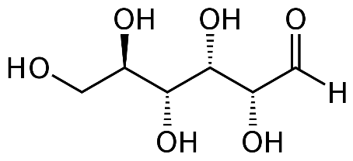
Structure of Dextrose

You will need to refer to these chemical equations and the structure of dextrose for the lab questions.

Materials:
Ammonium, NH₃ | 4 – 10ml graduated cylinders
Dextrose Solution, C₆H₁₂O₆ | Rubber stopper for flask
Silver nitrate solution, AgNO₃ | Distilled water
Sodium hydroxide solution, NaOH
Beaker
2 Test Tubes

Hazards:
Sodium hydroxide solution is a very corrosive liquid and is especially dangerous to the eyes. Ammonium solution is toxic when ingested, also it smells awful. Silver nitrate solution will stain your skin and clothing a deep brown. If the mixture of all the solutions is left for too long, it will form a contact explosive mixture. Make sure to rinse the mixture down the drain with a generous amount of water immediately after silver plating has occurred. Safety goggles for this lab is mandatory.

Procedure:

- In a beaker combine 1 mL of ammonia solution and 3 mL of silver nitrate solution. Use a clean 10-mL graduated cylinder to measure each solution.

- Pour the following solutions into each of the test tubes in the order indicated:

- 2 ml of dextrose solution
- 2 ml of the combined ammonia/silver nitrate solution from step 1

- Quickly but carefully pour 2mL of sodium hydroxide solution into each of the test tubes and stopper the test tubes.

- Shake the test tubes for 3 minutes and observe what happens.

- Once the test tubes are completely coated immediately pour the liquid from the test tubes down the drain and follow it with a generous amount of water.

- Gently, but thoroughly, rinse the flask with distilled water from a wash bottle and continue to run water down the drain for at least two minutes. Keep your test tubes.
Lab Questions

- What happened to the flask? What atom caused this

- Look at the structure of dextrose again. Determine the hybridization of each of the carbon atoms.
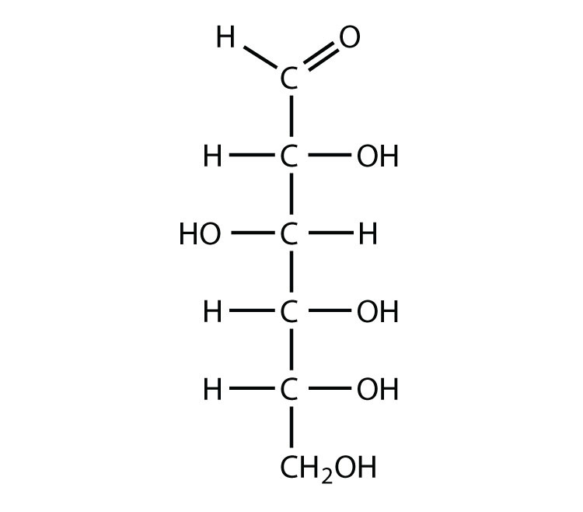

- The structure of dextrose stays constant after the reaction except for one piece of it, using your hybridizations from the previous problem, circle the functional group, (carbon atom with bonds), where you believe the reaction occurs.

- NO₃⁻ is an ion that is formed in this reaction. Determine the hybridization of the nitrogen and oxygen atoms in this molecule.

