Name: Period:

PS Unit 2 – Chemical Bonding
Periodic Table Worksheet

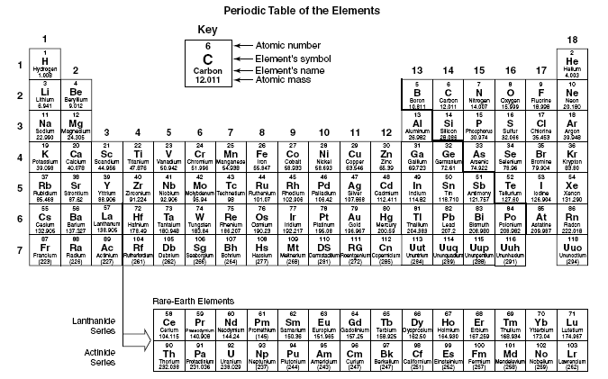

Directions: Use the periodic table above to answer the following questions.
1. List two types of information that are given in each box of this periodic table.
a.
b.
2. In this table, where are the metals located?
3. Where are the nonmetals located?
4. What are the elements in Groups 3 through 12 called?
5. What are the elements called that are next to the stairstep-shaped line on the
right side of the table?
6. What do we call the letter or letters that represents an element?

7. How many elements are included on this periodic table?
8. What name is given to the elements in Group 18?

