Name: Period:

PSB Unit 1 - Matter
Matter and Thermal Energy Worksheet

Directions: Look carefully at the graph. It was drawn from the data collected when a substance was heated at a constant rate. To heat at a constant rate means to add heat evenly as time passes. Use the graph to complete the paragraphs that follow.

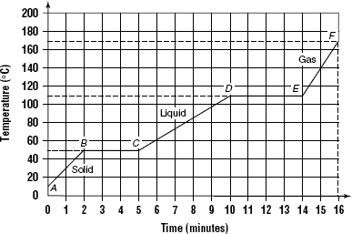

At the start of observations, Point A, the substance exists in the 1.
state. The temperature at this point is 2. . As energy is absorbed, the
temperature of the substance rises at a constant rate for two minutes. At Point B, the temperature is
3. , and the solid begins to 4. . The
temperature remains constant until the change from solid to 5. is
complete. It has taken three minutes to add enough energy to melt the solid completely. From
Point C to Point D, the substance is in the 6. state. Its temperature rises
at a constant rate to 7. . The temperature remains constant while the
liquid changes to a 8. . At Point E, the substance exists as a
9. . Its temperature rises evenly as energy is added.
When the gaseous substance is allowed to cool, it releases energy. The cooling curve will
be the reverse of the warming curve. Energy will be released as the substance changes
from a 10. to a 11. and also from a
12. to a 13. . The amount of energy released
during condensation will be the same as the amount absorbed during vaporization.

Bimetallic Strips
When heated, different materials expand at different rates. A strip of metal can be made of
brass and iron bonded together. This piece of metal is called a bimetallic strip, Figure 1.
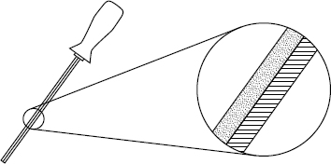
Figure 1

Brass

Iron

Bimetallic Strip

When heated, the brass and iron parts of a bimetallic strip expand. However, the brass expands
more than the iron expands. This causes the strip to bend.

1. Why do you think the bimetallic strip bends?

2. Figure 2 shows a bent bimetallic strip that has been heated. Label the diagram to indicate the
brass side and the iron side.
Figure 3
Figure 2
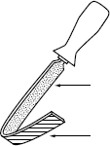
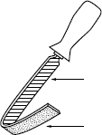

c.
a.

d.
b.

3. What do you think would happen when a bimetallic strip is cooled below room temperature?
Explain your answer.

4. Figure 3 shows a bent bimetallic strip that has been cooled. Label the diagram to indicate the
brass side and the iron side.

5. Bimetallic strips are used in many thermostats. Find out how a bimetallic strip works in a
thermostat.

