Article 2

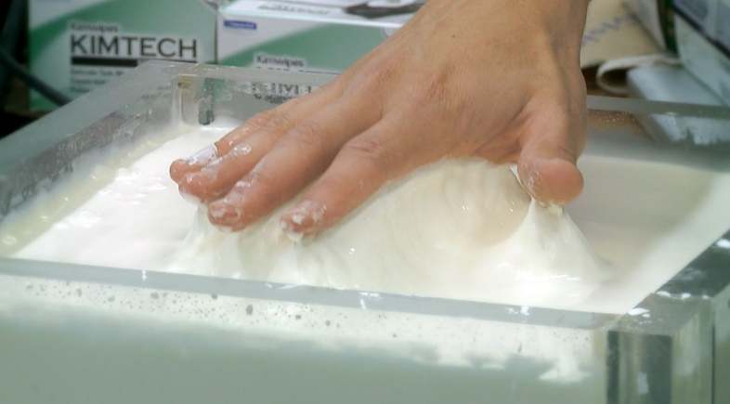
Walking on water

Scientists explain why a liquid can sometimes act like a solid

BY STEPHEN ORNES
JULY 30, 2012

Almost anyone can tell the difference between a liquid and a solid. A liquid flows. A solid stays put. You pour a liquid and push a solid. The difference seems as clear as water and ice.
But some stuff doesn't fit neatly into either group, like the goop you get by dissolving cornstarch in water. (Cornstarch is corn flour that helps thicken pie fillings and gravies.) The concoction looks like a liquid, and can be stirred gently with your hand or a spoon. But appearances are deceiving: Fill a swimming pool with the stuff, and you can run across the surface without getting wet. It's a good party trick — or a launching point for a science fair experiment.
“If you were to punch [it], you might break your wrist,” Scott Waitukaitis, a physicist from the University of Chicago, told Science News. He and other physicists often study the behavior of different states of matter to understand natural forces.
After watching videos of people dashing across water-cornstarch soup, Waitukaitis decided to investigate. In a new study, he and a colleague reveal the science behind the stuff that's sometimes liquid and sometimes solid.
The scientists smacked the liquid with a metal rod and then recorded the event using high-speed video and an x-ray camera. To understand, they analyzed the data using a computer program.
The results suggest that when the rod hit the surface, the impact pushed the water molecules away. That left only the particles of cornstarch, which squeezed together acting like they were a solid. And like a solid, the clump of cornstarch stopped the metal rod. The scientists reported in Nature.
Those observations may explain the strange suspension. When you slip your hand beneath the surface, water and cornstarch particles remain mixed together. But when you slap the mix — or run across —the water flows out and the cornstarch stands firm.
Daniel Bonn, a physicist at the University of Amsterdam, has conducted his own research on the cornstarch solution, by shooting bullets into the goo. He says he isn't surprised by the new result, “but the experiment was interesting because they’re able to look inside the cornstarch as it thickens.”
Cornstarch and water explained by physicists. Credit: UChicago Creative, University of Chicago News Office.
Article 2 Questions
- How did physicist Scott Waitukaitis and his team study the unique water-cornstarch mixture?

- What conclusions did they make about how the mixture reacted?

- Describe the difference between the goo’s reaction when a hand is slipped into the mixture in contrast to the goo being slapped.

- How did Daniel Bonn of the University of Amsterdam conduct his research on the water-cornstarch goo?

