Physics Applied Practice

- The three guitar strings below are made of the same material and have the same tension. Circle the one which will produce the highest frequency of sound and explain why.

- Two people face away from each other and start running directly north and south respectively. An ambulance travelling from North-East to South-West is within earshot of both the people running. Assuming the people do not run nearly as fast as the ambulance, what is the location of the ambulance with respect to the origin when both people hear a lower frequency shifted sound? (Location as in North, East, Origin etc.)

- If the sound of your voice has the frequencies it makes in the graph below, what happens to the graph when you inhale helium and speak.

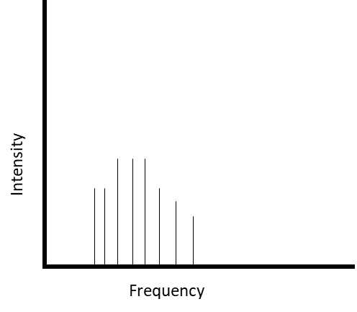

- Three instruments frequency spectra are given. Which instrument produces a higher pitch?

Instrument 1

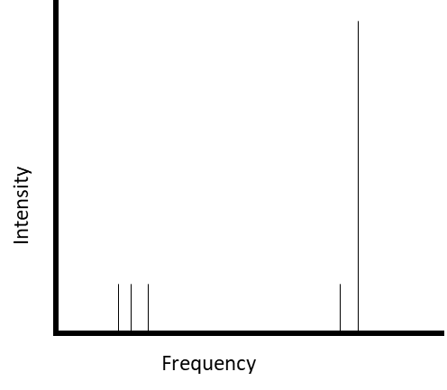

Instrument 2

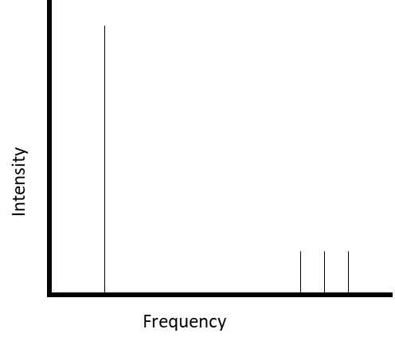
Instrument 3

- Two wine glasses made out of the same material are analyzed by some physicists. One wine glass has a smaller radius in it’s opening than the other wine glass. Which wine glass will have a higher natural excitation frequency?

- Sound is played at two solid materials. The first one has a lower density but a higher resistance to compressibility. The second has a higher density but is very compressible. In what material does the sound travel faster in?

- Which travels faster? Earthquakes or sound in air? Explain.

- Is it possible for a beat to have a higher frequency than the average frequency of the two waves that make it up? Explain.

