Organic Chemistry Applied Practice

- What is the general formula for a noncyclic alkane? C?H?

- If a noncyclic alkane contains 13 Carbon atoms how many hydrogens does it contain?

- Draw the structure of the following types of hydrocarbons using four carbon atoms.

- Two noncyclic alkanes.

- Two cyclic alkanes

- Give the molecular formula and structure for 4-ethyl-2,3-dimethylheptane

Molecular Formula:

Structure:

- Give the molecular formula and structure for 3,3-diethyloctane

Molecular Formula:

Structure:

- Give the molecular formula and structure for 4-propylheptane

Molecular Formula:

Structure:

- Give the molecular formula and structure for 3,3-diethyl-2,4-dimethylhexane

Molecular Formula:

Structure:

- Give the molecular formula and structure for 1,3-dimethyl-2-ethyl-4propylcyclohexane

Molecular Formula:

Structure:

- Name the following molecule.

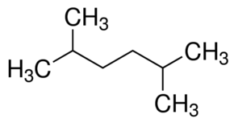

- Name the following molecule.
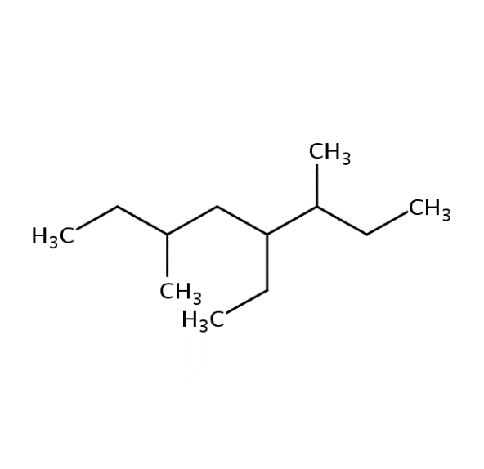

- Name the following molecule.

- Name the following molecule.

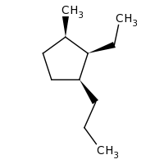

- What does it mean for a molecule to be aromatic?

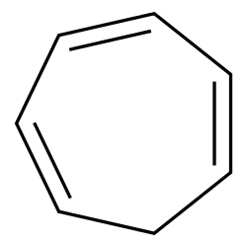
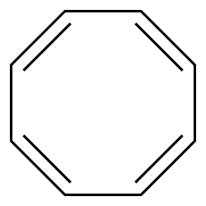
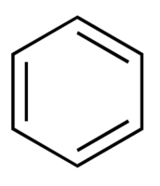
- Circle the aromatic rings below.

