Liquids and Solids Applied Practice

- Why is a burn from steam typically more severe than a burn from boiling water? Explain using a phase change diagram.

- Determine the strongest intermolecular force in the following compounds.

Kr | CS₂
H₂S | CH₄
HI | CO
CO₂ | NF₃

- Circle the molecule in each pair that will have a higher boiling point.

- H₂O or H₂S

- C₂H₆ or C₂H₅OH

- P₄ or As₄

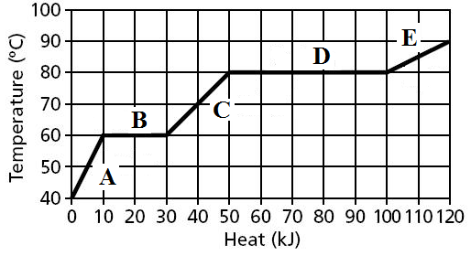
- Use the following Heating Curve. Identify the following from the graph. If the question asks for a part of the graph, use the letter associated with the appropriate line segment.

a. What is the boiling point?

b. Where is the substance a solid?

c. Where is the Heat of Fusion?

d. What is the condensation point?

e. Where is the substance a gas?

f. What is the freezing point?

- What would happen to the above graph if the intermolecular forces became stronger? Describe and sketch a before and after graph of what would happen. (Numbers don’t matter)

- What quantity of energy does it take to convert 0.250 kg of ice at -15.0 $℃$ to steam at 300.0 $℃$? The specific heat capacities are: Ice, 2.03 J/g$℃$; Liquid, 4.18 J/g$℃$; steam 2.02 J/g$℃$;
H_{vap} = 40.7 kJ/mol; H_{fus} = 6.02 kJ/mol.

- When mercury is measured in a graduated cylinder it forms a convex bubble instead of a concave bubble like water. What is causing the convex bubble instead of the concave bubble?

- Based on the following diagram below answer the following questions. If a point does not exist answer not shown.
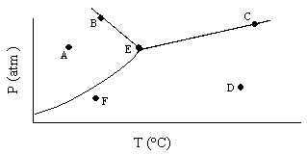

a. Where is the substance a gas?

b. Where is the substance a solid?

c. Where is the triple point?

d. Where is the critical point?

e. Where is the substance a liquid?

f. Where is the equilibrium line?

